|  |  |
| --- | --- |
| Project Title | **E-commerce Furniture Dataset 2024** |
| Tools | Python, ML, SQL, Excel |
| Domain | Data Analyst |
| Project Difficulties level | Beginner |

Dataset : Dataset is available in the given link. You can download it at your convenience.

[Click](https://drive.google.com/file/d/1EwYcFTnjwuZTpdfd2uaKjNVDLPmRsSMD/view?usp=sharing) [here](https://drive.google.com/file/d/1EwYcFTnjwuZTpdfd2uaKjNVDLPmRsSMD/view?usp=sharing) [to](https://drive.google.com/file/d/1EwYcFTnjwuZTpdfd2uaKjNVDLPmRsSMD/view?usp=sharing) [download](https://drive.google.com/file/d/1EwYcFTnjwuZTpdfd2uaKjNVDLPmRsSMD/view?usp=sharing) [data](https://drive.google.com/file/d/1EwYcFTnjwuZTpdfd2uaKjNVDLPmRsSMD/view?usp=sharing) [set](https://drive.google.com/file/d/1EwYcFTnjwuZTpdfd2uaKjNVDLPmRsSMD/view?usp=sharing)

**About Dataset**

**Dataset Overview:**

This dataset comprises 2,000 entries scraped from AliExpress, detailing a variety of furniture products. It captures key sales metrics and product details, offering a snapshot of consumer purchasing patterns and market trends in the online furniture retail space.

**Data Science Applications:**

The dataset is ripe for exploratory data analysis, market trend analysis, and price optimization studies. It can also be used for predictive modeling to forecast sales, understand the impact of discounts on sales volume, and analyze the relationship between product features and their popularity.

**Column Descriptors:**

* productTitle: The name of the furniture item.
* originalPrice: The original price of the item before any discounts.
* price: The current selling price of the item.
* sold: The number of units sold.
* tagText: Additional tags associated with the item (e.g., "Free shipping").

**Ethically Collected Data:**

The data was collected in compliance with ethical standards, ensuring respect for user privacy and platform terms of service.

**Acknowledgements:**

This dataset was created with data sourced from AliExpress, using Apify for scraping. The thumbnail image was generously provided by Spacejoy on Unsplash. We extend our gratitude to these parties for their contributions to this dataset.

Photo by [Spacejoy](https://unsplash.com/@spacejoy?utm_content=creditCopyText&utm_medium=referral&utm_source=unsplash) on [Unsplash](https://unsplash.com/photos/a-living-room-filled-with-furniture-and-a-mirror-c0JoR_-2x3E?utm_content=creditCopyText&utm_medium=referral&utm_source=unsplash).

**Example: You can get the basic idea how you can create a project from here**

|  |
| --- |
| **Project Overview:**  ● **Objective**: Predict the number of furniture items sold (sold) based on product attributes such as productTitle, originalPrice, price, and tagText. ● **Tech Stack**: Python, pandas, scikit-learn, matplotlib, seaborn **Steps:**   1. **Data Collection** 2. **Data Preprocessing** 3. **Exploratory Data Analysis (EDA)** 4. **Feature Engineering** 5. **Model Selection & Training** 6. **Model Evaluation** 7. **Conclusion**   **1. Data Collection**  In this step, we assume that the dataset is available in CSV format. We can load it using pandas.  # Import necessary libraries import pandas as pd  # Load dataset df = pd.read_csv('ecommerce_furniture_dataset.csv') |

|  |
| --- |
| # View the first few rows of the dataset print(df.head())   1. **Data Preprocessing**   We will clean the data by handling missing values, converting categorical variables, and removing irrelevant columns.  # Check for missing values print(df.isnull().sum())  # Dropping any rows with missing values (if applicable) df = df.dropna()  # Converting tagText into a categorical feature (if necessary) df['tagText'] = df['tagText'].astype('category').cat.codes  # Checking for data types and conversions if necessary print(df.info())   1. **Exploratory Data Analysis (EDA)**   Visualize the relationships between features and the target variable (sold).  Understand the distribution and trends in the data. |

|  |
| --- |
| import seaborn as sns import matplotlib.pyplot as plt  # Distribution of 'sold' values sns.histplot(df['sold'], kde=True) plt.title('Distribution of Furniture Items Sold') plt.show()  # Plot the relationship between originalPrice, price and sold sns.pairplot(df, vars=['originalPrice', 'price', 'sold'], kind='scatter')  plt.title('Relationship Between Price, Original Price, and Items Sold') plt.show()  **4. Feature Engineering**   1. **Handling Product Titles**: We will convert productTitle to numerical features using techniques like **TF-IDF**. 2. **Price and Discount Feature**: Create a new feature to calculate the percentage discount from originalPrice and price.   from sklearn.feature_extraction.text import TfidfVectorizer |

|  |
| --- |
| # Create a new feature: percentage discount df['discount_percentage'] = ((df['originalPrice'] df['price']) / df['originalPrice']) * 100  # Convert productTitle into a numeric feature using TF-IDF Vectorizer tfidf = TfidfVectorizer(max_features=100) productTitle_tfidf = tfidf.fit_transform(df['productTitle'])  # Convert to DataFrame and concatenate to original df productTitle_tfidf_df = pd.DataFrame(productTitle_tfidf.toarray(), columns=tfidf.get_feature_names_out()) df = pd.concat([df, productTitle_tfidf_df], axis=1)  # Drop original productTitle as it's now encoded df = df.drop('productTitle', axis=1)  **5. Model Selection & Training**  We will use **Linear Regression** and **Random Forest Regressor** as models to predict the number of items sold.  from sklearn.model_selection import train_test_split from sklearn.linear_model import LinearRegression |

|  |
| --- |
| from sklearn.ensemble import RandomForestRegressor from sklearn.metrics import mean_squared_error, r2_score  # Split the dataset into features (X) and target (y) X = df.drop('sold', axis=1) y = df['sold']  # Train-test split (80% train, 20% test)  X_train, X_test, y_train, y_test = train_test_split(X, y, test_size=0.2, random_state=42)  # Initialize models lr_model = LinearRegression() rf_model = RandomForestRegressor(n_estimators=100, random_state=42)  # Train models lr_model.fit(X_train, y_train) rf_model.fit(X_train, y_train)  **6. Model Evaluation**  We evaluate the model's performance using **mean squared error (MSE)** and **R-squared** metrics. |

|  |
| --- |
| # Predict with Linear Regression y_pred_lr = lr_model.predict(X_test) mse_lr = mean_squared_error(y_test, y_pred_lr) r2_lr = r2_score(y_test, y_pred_lr)  # Predict with Random Forest y_pred_rf = rf_model.predict(X_test) mse_rf = mean_squared_error(y_test, y_pred_rf) r2_rf = r2_score(y_test, y_pred_rf)  # Print model evaluation results print(f'Linear Regression MSE: {mse_lr}, R2: {r2_lr}') print(f'Random Forest MSE: {mse_rf}, R2: {r2_rf}')  **7. Conclusion**  After evaluating the models, we can conclude which model performed better and further tune hyperparameters if needed. Random Forest tends to perform better on complex datasets with high variance, while Linear Regression might work well if relationships are linear.  **Output:**   1. **Linear Regression Model**: MSE and R-squared score. 2. **Random Forest Model**: MSE and R-squared score. |

**NOTE :**

1. **this project is only for your guidance, not exactly the same you have to create. Here I am trying to show the way or idea of what steps you can follow and how your projects look. Some projects are very advanced (because it will be made with the help of flask, nlp, advance ai, advance DL and some advanced things ) which you can not understand .**
2. **You can make or analyze your project with yourself, with your idea, make it more creative from where we can get some information and understand about our business. make sure what overall things you have created all things you understand very well.**

**Example: You can get the basic idea how you can create a project from here**

**Sample code with output**

|  |
| --- |
| *# This Python 3 environment comes with many helpful analytics libraries installed*  *# It is defined by the kaggle/python Docker image:*  *https://github.com/kaggle/docker-python*  *# For example, here's several helpful packages to load*  import numpy as np *# linear algebra* import pandas as pd *# data processing, CSV file I/O (e.g. pd.read_csv)*  *# Input data files are available in the read-only "../input/" directory*  *# For example, running this (by clicking run or pressing Shift+Enter) will list all files under the input directory*  import os for dirname, _, filenames **in** os.walk('/kaggle/input'):  for filename **in** filenames:  print(os.path.join(dirname, filename))  *# You can write up to 20GB to the current directory*  *(/kaggle/working/) that gets preserved as output when you create* |

|  |  |  |  |  |  |  |
| --- | --- | --- | --- | --- | --- | --- |
| *a version using "Save & Run All"*  *# You can also write temporary files to /kaggle/temp/, but they won't be saved outside of the current session*  /kaggle/input/e-commerce-furniture-dataset-2024/ecommerce_furni ture_dataset_2024.csv  In [2]: df =  pd.read_csv('/kaggle/input/e-commerce-furniture-dataset-2024/ec ommerce_furniture_dataset_2024.csv')  In [3]: df.head()  Out[3]:   |  |  |  |  |  |  | | --- | --- | --- | --- | --- | --- | |  | productTitle | original  Price | price | so  ld | tagText | |

|  |  |  |  |  |  |  |  |  |  |  |  |  |  |  |  |  |  |  |  |  |  |  |  |  |  |  |  |  |  |  |
| --- | --- | --- | --- | --- | --- | --- | --- | --- | --- | --- | --- | --- | --- | --- | --- | --- | --- | --- | --- | --- | --- | --- | --- | --- | --- | --- | --- | --- | --- | --- |
| |  |  |  |  |  |  | | --- | --- | --- | --- | --- | --- | | 0 | Dresser For Bedroom With 9 Fabric Drawers Ward... | NaN | $46.  79 | 60  0 | Free shipping | | 1 | Outdoor Conversation Set 4 Pieces Patio Furnit... | NaN | $169  .72 | 0 | Free shipping | | 2 | Desser For Bedroom With 7 Fabric Drawers Organ... | $78.4 | $39.  46 | 7 | Free shipping | | 3 | Modern Accent Boucle  Chair,Upholstered Tufted ... | NaN | $111.  99 | 0 | Free shipping | | 4 | Small Unit Simple Computer Desk Household Wood... | $48.82 | $21.  37 | 1 | Free shipping |   In [4]: df.isnull().sum()  Out[4]:  productTitle 0 |

originalPrice

1513

price

0

sold

0

tagText

3

dtype:

int64

In

[5]:

df

.

shape

Out[5]:

(2000

,

5)

In

[6]:

df

.

drop([

'originalPrice'

,axis

]

=

1

,inplace

=

True

)

In

[7]:

df

.

head()

Out[7]:

productTitle

price

so

tagText

|  |  |  |  |  |  |  |  |  |  |  |  |  |  |  |  |  |  |  |  |  |  |  |  |  |  |  |  |  |  |  |
| --- | --- | --- | --- | --- | --- | --- | --- | --- | --- | --- | --- | --- | --- | --- | --- | --- | --- | --- | --- | --- | --- | --- | --- | --- | --- | --- | --- | --- | --- | --- |
| |  |  |  |  |  | | --- | --- | --- | --- | --- | |  |  |  | ld |  | | 0 | Dresser For Bedroom With 9 Fabric Drawers Ward... | $46.  79 | 60  0 | Free shipping | | 1 | Outdoor Conversation Set 4 Pieces Patio Furnit... | $169  .72 | 0 | Free shipping | | 2 | Desser For Bedroom With 7 Fabric Drawers Organ... | $39.  46 | 7 | Free shipping | | 3 | Modern Accent Boucle  Chair,Upholstered Tufted ... | $111.  99 | 0 | Free shipping | | 4 | Small Unit Simple Computer Desk Household Wood... | $21.  37 | 1 | Free shipping |   In [8]: df['tagText'].nunique()  Out[8]: |

|  |
| --- |
| 100  In [9]: df['tagText'].value_counts()  Out[9]: tagText  Free shipping 1880  +Shipping: $5.09 9  +Shipping: $239.64 2  +Shipping: $97.54 2  +Shipping: $64.56 2  ...  +Shipping: $88.26 1  +Shipping: $170.31 1  +Shipping: $1,097.18 1  +Shipping: $106.13 1  +Shipping: $171.49 1  Name: count, Length: 100, dtype: int64  In [10]:  *# Replace all values except 'Free shipping' and '+Shipping:*  *$5.09' with 'others'* df['tagText'] = df['tagText'].apply(lambda x: x if x **in** ['Free |

shipping'

,

'+Shipping:

$5.09'

]

else

'others'

)

*#*

*Display*

*the*

*modified*

*value*

*counts*

print

(

df

[

'tagText'

]

.

value_counts())

tagText

Free

shipping

1880

others

111

+

Shipping

:

$5.09

9

Name:

count,

dtype:

int64

In

[11]:

import

seaborn

as

sns

In

[12]:

sns

.

countplot(x

=

'tagText'

,data

=

df)

Out[12]:

<

Axes

:

xlabel='tagText',

ylabel='count'>

In

[13]:

df[

'price'

]

=

df[

'price'

]

.

replace(

'[\$,]'

,

''

,

regex

=

True

)

.

astype(

float

)

In

[14]:

df

.

head()

Out[14]:

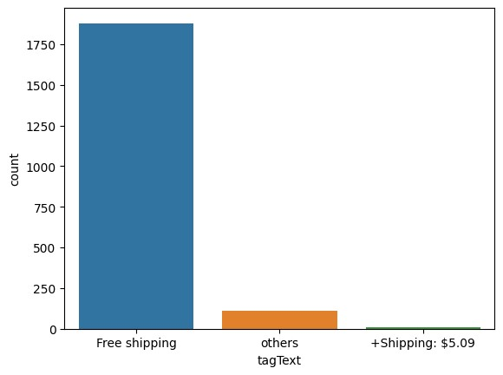

|  |  |  |  |  |  |  |  |  |  |  |  |  |  |  |  |  |  |  |  |  |  |  |  |  |  |  |  |  |  |  |
| --- | --- | --- | --- | --- | --- | --- | --- | --- | --- | --- | --- | --- | --- | --- | --- | --- | --- | --- | --- | --- | --- | --- | --- | --- | --- | --- | --- | --- | --- | --- |
| |  |  |  |  |  | | --- | --- | --- | --- | --- | |  | productTitle | pric  e | so  ld | tagText | | 0 | Dresser For Bedroom With 9 Fabric Drawers Ward... | 46.7  9 | 60  0 | Free shipping | | 1 | Outdoor Conversation Set 4 Pieces Patio Furnit... | 169.  72 | 0 | Free shipping | | 2 | Desser For Bedroom With 7 Fabric Drawers Organ... | 39.4  6 | 7 | Free shipping | | 3 | Modern Accent Boucle  Chair,Upholstered Tufted ... | 111.  99 | 0 | Free shipping | | 4 | Small Unit Simple Computer Desk Household Wood... | 21.3  7 | 1 | Free shipping |   In [15]:  sns.distplot(df['price']) |

|  |
| --- |
| /tmp/ipykernel_18/444587821.py:1: UserWarning:  `distplot` is a deprecated function and will be removed in seaborn v0.14.0.  Please adapt your code to use either `displot` (a figure-level function with similar flexibility) or `histplot` (an axes-level function for histograms).  For a guide to updating your code to use the new functions, please see https://gist.github.com/mwaskom/de44147ed2974457ad6372750bbe575  1  sns.distplot(df['price'])  /opt/conda/lib/python3.10/site-packages/seaborn/_oldcore.py:111 9: FutureWarning: use_inf_as_na option is deprecated and will be removed in a future version. Convert inf values to NaN before operating instead.  with pd.option_context('mode.use_inf_as_na', True): |

Out[15]:

<

Axes

:

xlabel='price',

ylabel='Density'>

In

[16]:

sns

.

distplot(df[

'sold'

])

/tmp/ipykernel_18/2507294489.py:1:

UserWarning:

`distplot`

is

a

deprecated

function

and

will

be

removed

in

seaborn

v0.14.0.

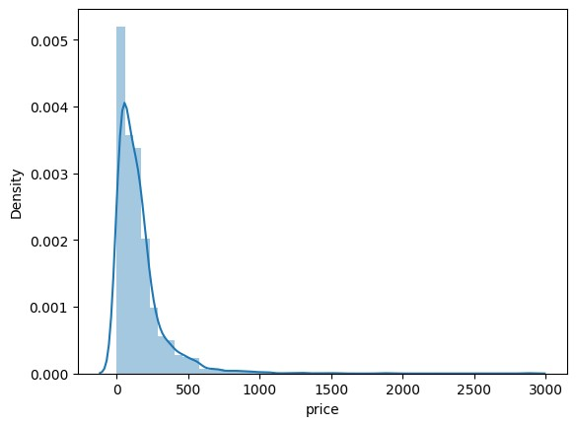

|  |
| --- |
| Please adapt your code to use either `displot` (a figure-level function with similar flexibility) or `histplot` (an axes-level function for histograms).  For a guide to updating your code to use the new functions, please see https://gist.github.com/mwaskom/de44147ed2974457ad6372750bbe575  1  sns.distplot(df['sold'])  /opt/conda/lib/python3.10/site-packages/seaborn/_oldcore.py:111 9: FutureWarning: use_inf_as_na option is deprecated and will be removed in a future version. Convert inf values to NaN before operating instead. with pd.option_context('mode.use_inf_as_na', True):  Out[16]:  <Axes: xlabel='sold', ylabel='Density'> |

In

[17]:

sns

.

scatterplot(x

=

'price'

,

y

=

'sold'

,

data

=

df)

Out[17]:

<

Axes

:

xlabel='price',

ylabel='sold'>

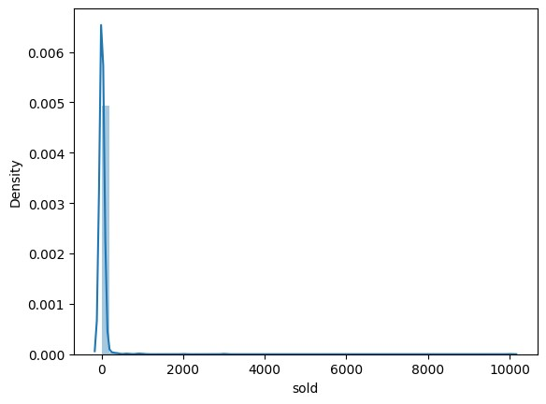

In

[18]:

filtered_df

=

df[df[

'tagText'

]

==

'Free

shipping'

]

*#*

*Create*

*a*

*pairplot*

*including*

*the*

*'sold'*

*column*

*and*

*other*

*relevant*

*columns*

sns

.

pairplot(filtered_df[[

'price'

,

'sold'

]])

/opt/conda/lib/python3.10/site-packages/seaborn/_oldcore.py:111

9:

FutureWarning:

use_inf_as_na

option

is

deprecated

and

will

be

removed

in

a

future

version.

Convert

inf

values

to

NaN

before

operating

instead.

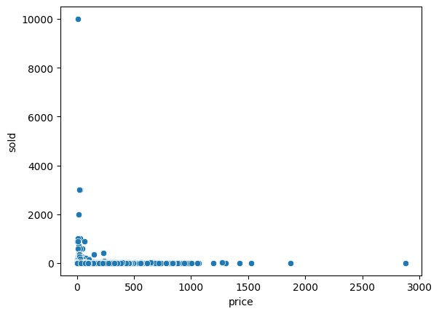

with

pd.option_context('mode.use_inf_as_na',

True):

/opt/conda/lib/python3.10/site-packages/seaborn/_oldcore.py:111

9:

FutureWarning:

use_inf_as_na

option

is

deprecated

and

will

be

removed

in

a

future

version.

Convert

inf

values

to

NaN

before

operating

instead.

with

pd.option_context('mode.use_inf_as_na',

True):

Out[18]:

<

seaborn.axisgrid.PairGrid

at

00>

0

x7b8ab4b8bd

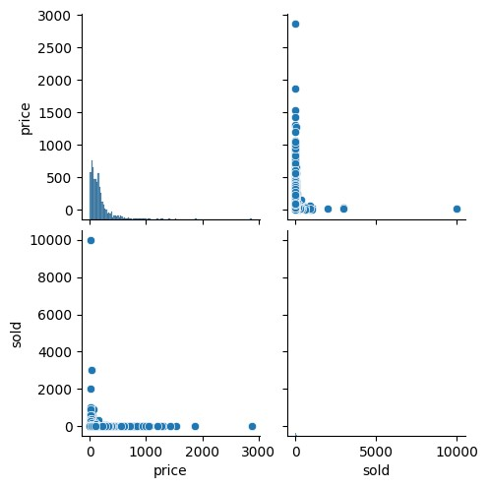

|  |  |  |  |  |  |  |  |  |  |  |  |  |  |  |  |  |  |  |  |  |
| --- | --- | --- | --- | --- | --- | --- | --- | --- | --- | --- | --- | --- | --- | --- | --- | --- | --- | --- | --- | --- |
| In [19]:  from sklearn.preprocessing import LabelEncoder le=LabelEncoder()  df['tagText']=le.fit_transform(df['tagText'])  In [20]: df.head()  Out[20]:   |  |  |  |  |  | | --- | --- | --- | --- | --- | |  | productTitle | pric  e | so  ld | tagT ext | | 0 | Dresser For Bedroom With 9 Fabric Drawers Ward... | 46.7  9 | 60  0 | 1 | | 1 | Outdoor Conversation Set 4 Pieces Patio Furnit... | 169.  72 | 0 | 1 | | 2 | Desser For Bedroom With 7 | 39.4 | 7 | 1 | |

|  |  |  |  |  |  |  |  |  |  |  |  |  |  |  |  |
| --- | --- | --- | --- | --- | --- | --- | --- | --- | --- | --- | --- | --- | --- | --- | --- |
| |  |  |  |  |  | | --- | --- | --- | --- | --- | |  | Fabric Drawers Organ... | 6 |  |  | | 3 | Modern Accent Boucle  Chair,Upholstered Tufted ... | 111.  99 | 0 | 1 | | 4 | Small Unit Simple Computer Desk Household Wood... | 21.3  7 | 1 | 1 |   In [21]: df['tagText'].value_counts()  Out[21]: tagText   1. 1880 2. 111   0 9  Name: count, dtype: int64  In [ ]: |

[Reference](https://github.com/ahjimomo/E-commerce_customer_reviews_classification) [link](https://github.com/ahjimomo/E-commerce_customer_reviews_classification)